- Date

OPTIONS:
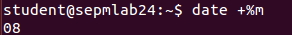
1.2) date +%m


1.3)date +%h

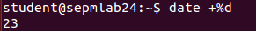
1.4)date +%d

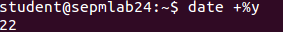
1.5)date +%y


1.6)date +%H

1.7)date +%M

1.8)date +%S

1.9)date +%T

1.10)date +”%d %h %y”

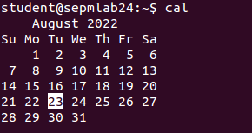
2)cal

OPTIONS:
2.1)cal 04 1988
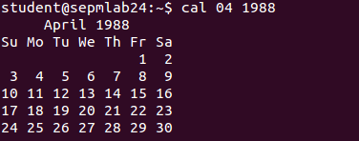

2.2)cal 2002
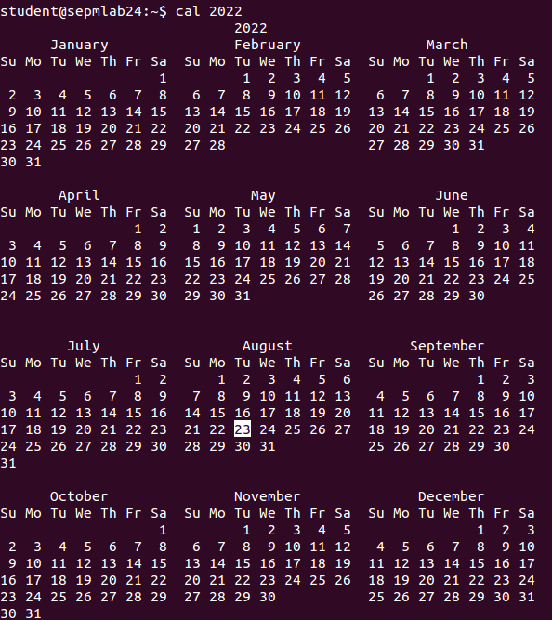

3)who am i

4) ps
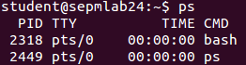

5) ls

OPTIONS:
5.1) ls -x

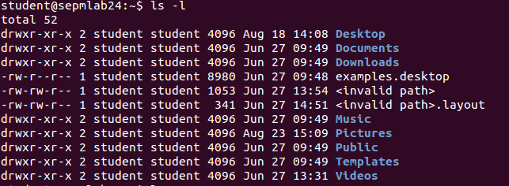
5.2) ls -l
5.3)l s -f
5.4) ls -a
6)wc file_name
File:
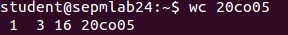
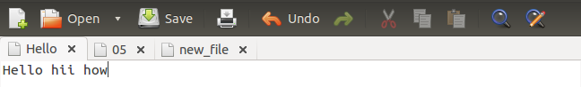
OPTIONS:
6.1)wc -l file_name
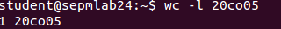

6.2)wc -w file_name
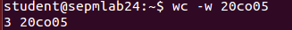

6.3)wc -c file_name

7)cat file_name


OPTIONS:
7.1)cat > new_file

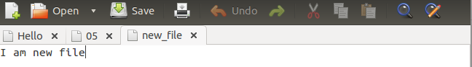

8) ls | wc -l
8.1) ls using metacharacters (* , > , | )

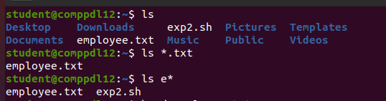

9)man command_name
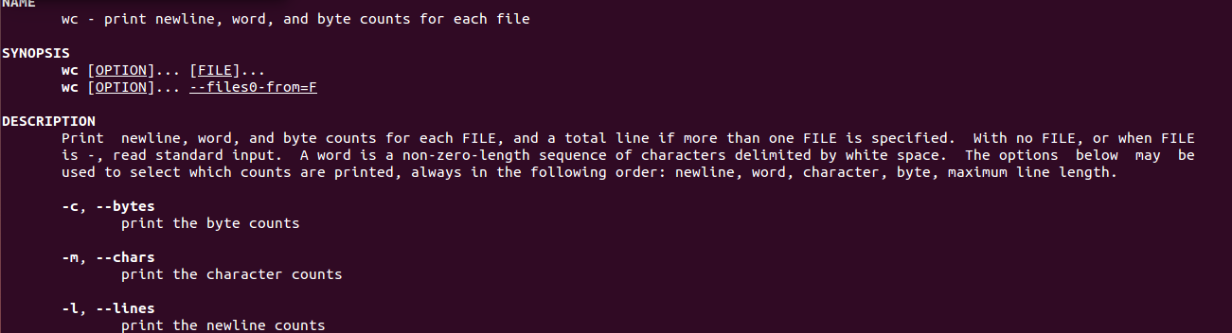
10)echo “string_to_be_printed”

11)ls first_char*
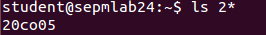

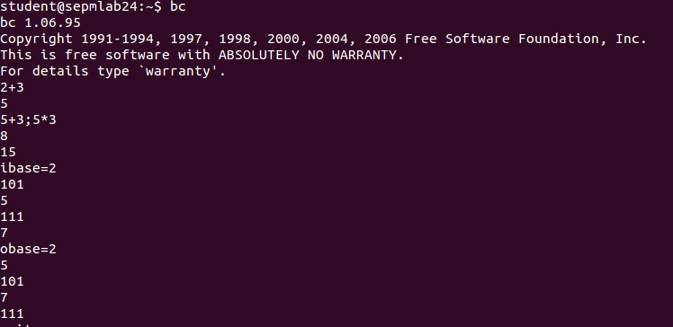
12) bc

13)type wc


14)script
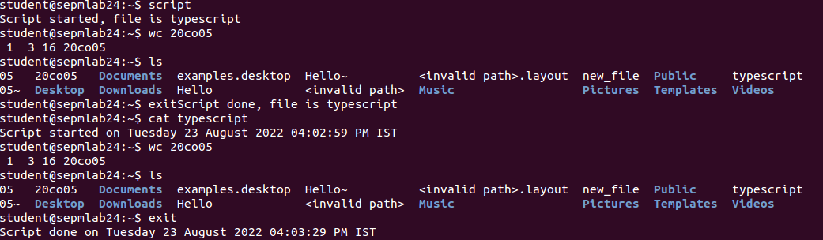
14.1)script -a
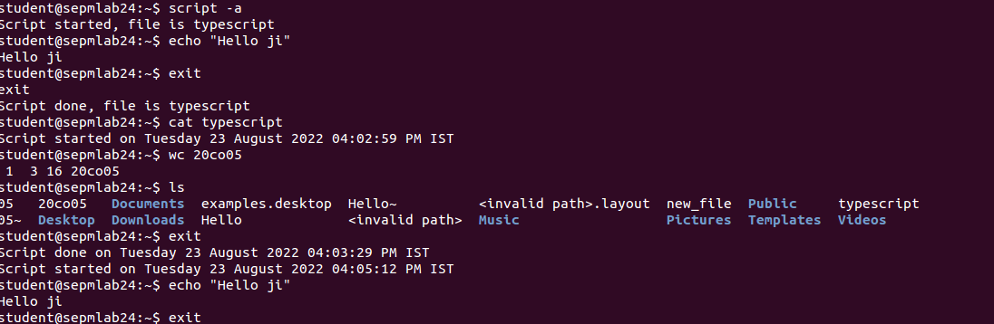
15)passwd


16)uname
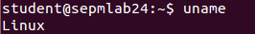
OPTIONS:

16.1)uname -i
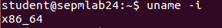

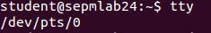
17)tty

18)pwd
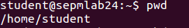
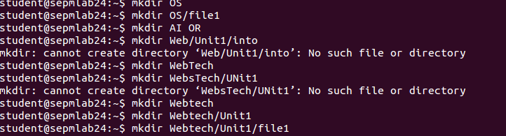
19)mkdir


20)cd


21)cd ..

22)rmdir
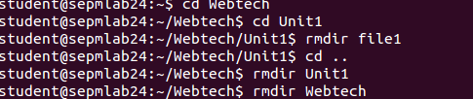

23)cp
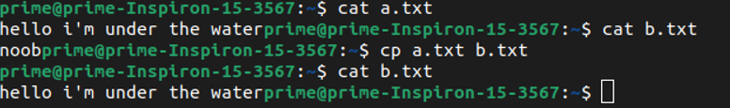
OPTIONS:
23.1) cp -i

24) rm
OPTIONS:
24.1) rm -i

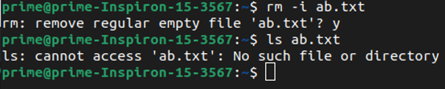
25)mv

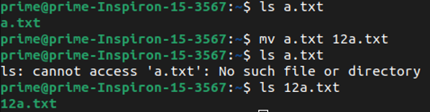
26) cmp

27) chmod [relative and absolute] -> At last

28)Shell variable declaration and display value
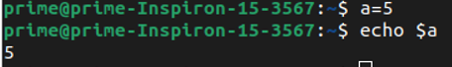

29) head
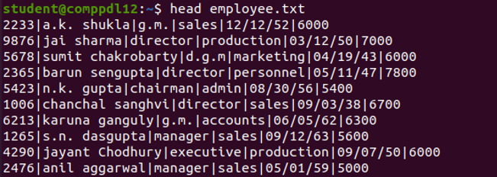
OPTIONS:
29.1) head -n
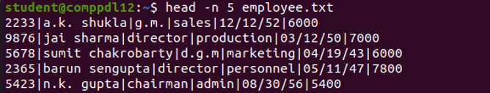

30) tail
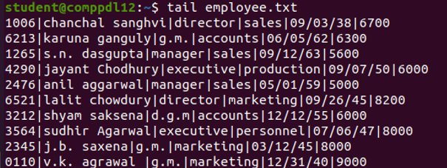

OPTIONS:
30.1) tail -n
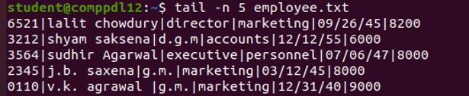

31) cut
OPTIONS:
31.1) cut -c
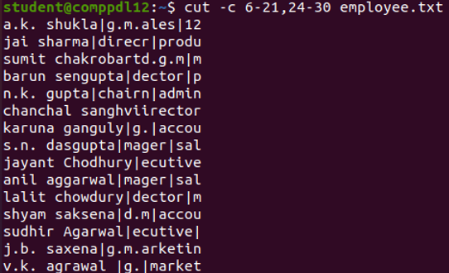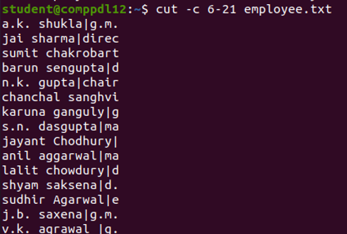
31.2) cut -f
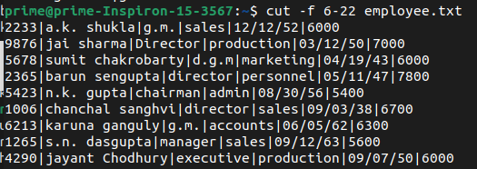

32) sort
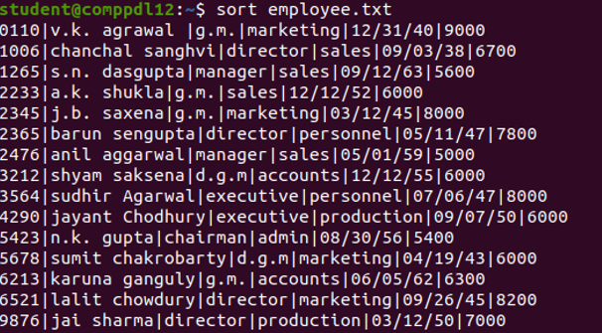

OPTIONS
32.1)sort -t
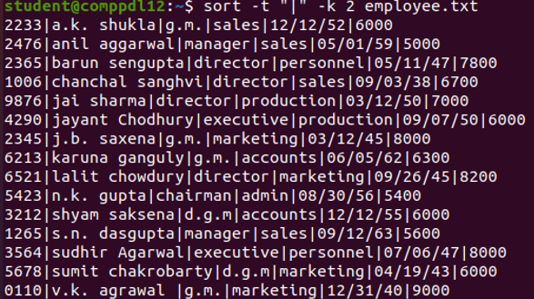

32.2)sort -r
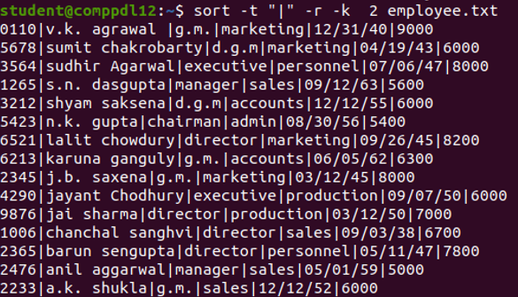

32.3) sort -k
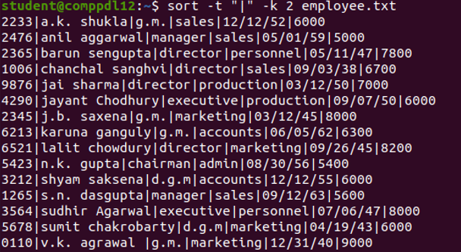
32.4) sort -r -k
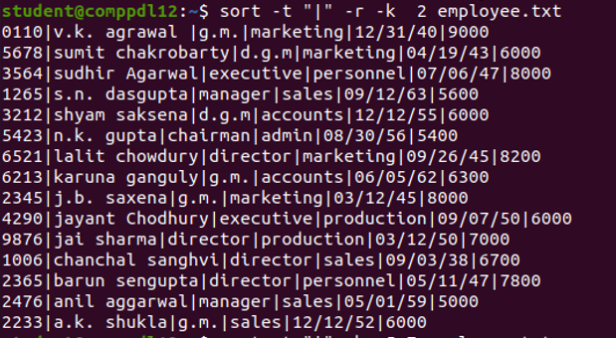

33) tr
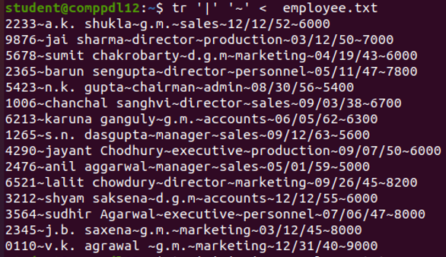

33.1) tr on head
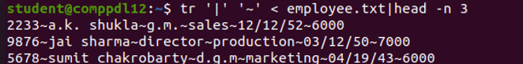
33.2) tr on tail
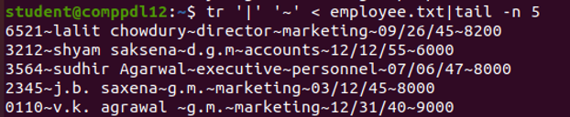

33.3) tr -d
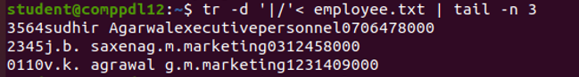

33.4) tr [changing cases]
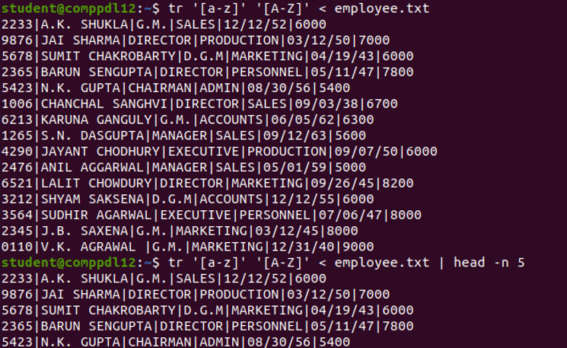
33.5) tr -s
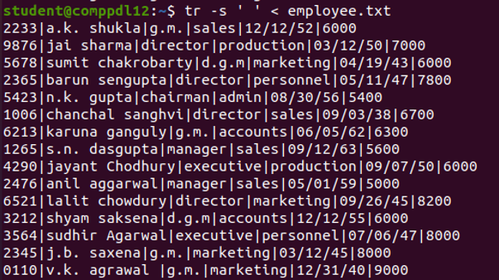

34) grep
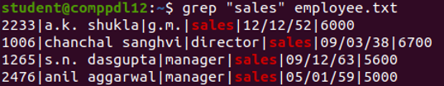

OPTIONS:
34.1) grep -i
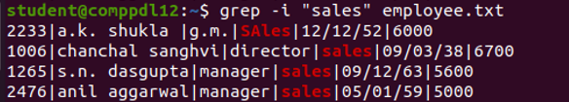
34.2) grep -v
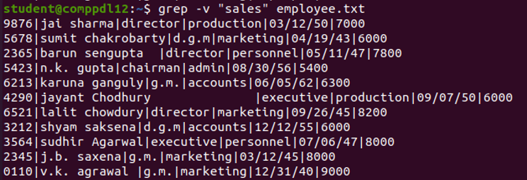

34.3) grep -c
34.4) grep -e
34.5) grep -l
34.6) grep [pattern]
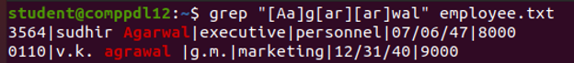35) chmod
OPTIONS: {Relative)
Initial status:
35.1) Giving user execute right
35.2) Taking away execute write from user and group (ug)
35.3)Giving access to write to all three (ugo)
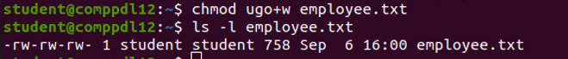
OPTIONS: (Absolute) [5 - r & x to user, 6 - r & w to group, 4 – r only for other)


